Sales Data Analysis Project
Using Hadoop HDFS, Apache Pig & Apache Hive
Cloudera QuickStart VM • Practical

Project Overview
This report documents a hands-on big data project performed on the Cloudera QuickStart Virtual Machine. The objective was to create a sales dataset, upload it to the Hadoop Distributed File System (HDFS), analyze it using Apache Pig (a high-level data flow scripting language), and query it using Apache Hive (a SQL-like data warehouse tool). Each step is documented with screenshots, explanations, and key insights derived from the analysis.

Step 1: Creating the Sales Dataset

What Was Done
A CSV (Comma-Separated Values) file named sales_data.csv was created using the nano text editor on the Cloudera terminal. The command used was:
$ nano sales_data.csv
The nano editor opened an empty file in the terminal where the sales data was typed manually. After entering the data, the file was saved using Ctrl+O and the editor was exited with Ctrl+X.

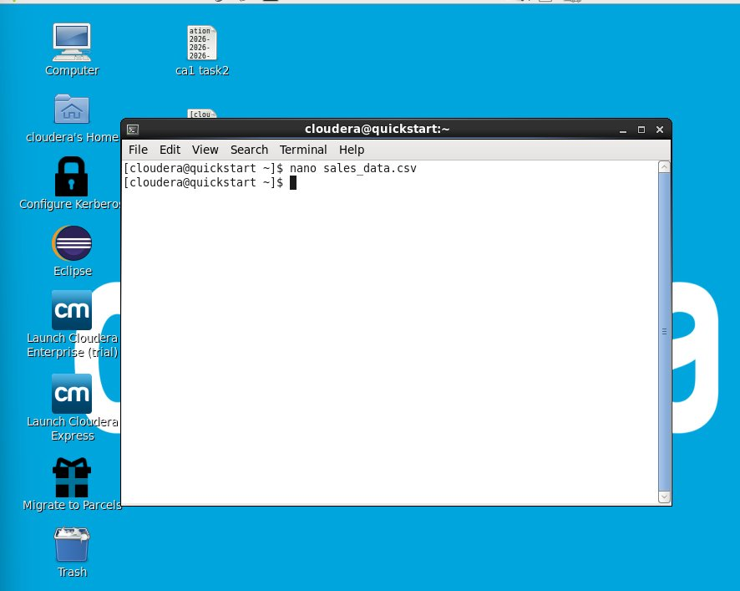
Screenshot 1: Opening nano text editor to create sales_data.csv

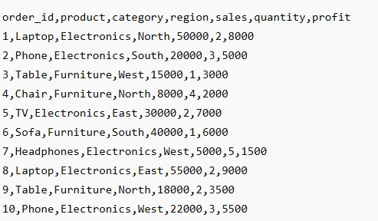
Screenshot 2: Contents of sales_data.csv — 10 records with order_id, product, category, region, sales, quantity, profit

Key Insights
• The dataset contains 10 sales records spanning 4 regions: North, South, East, and West.
• Two product categories are present: Electronics and Furniture.
• Electronics products (Laptop, Phone, TV, Headphones) generally yield higher sales values than Furniture.
• The highest single sale is Laptop in East at ₹55,000 with a profit of ₹9,000.
• CSV format is chosen as it is lightweight, universally readable, and compatible with Hadoop tools.

Step 2: Uploading Data to HDFS

What Was Done
After creating the file locally, it was uploaded to the Hadoop Distributed File System (HDFS). HDFS is the storage layer of Hadoop, designed to store large datasets across multiple nodes reliably. Three commands were executed in sequence:
$ hdfs dfs -mkdir -p /user/cloudera/sales_project
$ hdfs dfs -put sales_data.csv /user/cloudera/sales_project
$ hdfs dfs -ls /user/cloudera/sales_project
The first command creates the directory in HDFS, the second uploads the local CSV file to that directory, and the third verifies the file was successfully uploaded by listing its details (permissions, size: 434 bytes, timestamp).
Note: A java.lang.InterruptedException warning appeared during the upload. This is a known non-fatal warning in the older Cloudera CDH 5 environment and did not affect the file transfer. The listing confirmed the file was successfully stored.

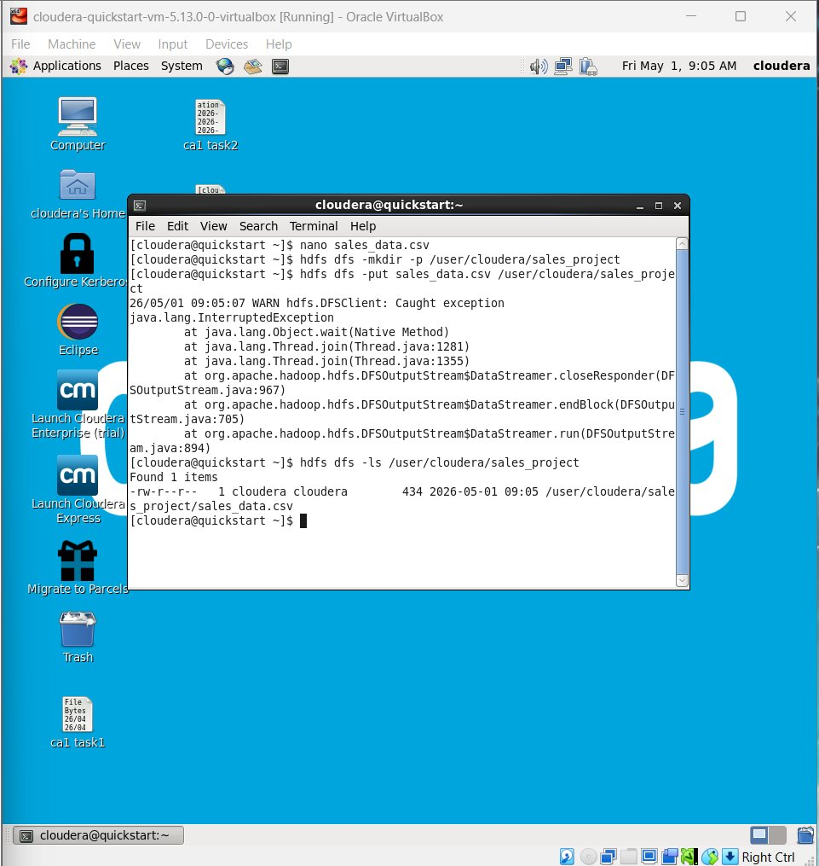
Screenshot 3: HDFS directory creation, file upload, and verification listing

Key Insights
• HDFS stores files in a distributed manner, providing fault tolerance and high availability for big data workloads.
• The -mkdir -p flag ensures parent directories are created if they do not exist.
• The -put command moves data from the local filesystem into the HDFS namespace.
• The file size of 434 bytes confirms all 10 records were saved correctly.
• The InterruptedException warning is benign and is common in CDH 5.x environments — it does not indicate data loss.

Step 3: Launching Apache Pig

What Was Done
Apache Pig was launched from the terminal by simply typing the command pig. Pig is a high-level data flow language (Pig Latin) built on top of Hadoop that allows complex data transformations without writing low-level MapReduce Java code. Upon launch, Pig shows initialization logs and enters the interactive grunt> shell where Pig Latin statements can be executed.
$ pig
The initialization logs show the Apache Pig version (0.12.0-cdh5.13.0) and warnings about deprecated configuration properties (mapred.job.tracker and fs.default.name). These deprecation warnings are expected in Hadoop 2.x and do not affect functionality.

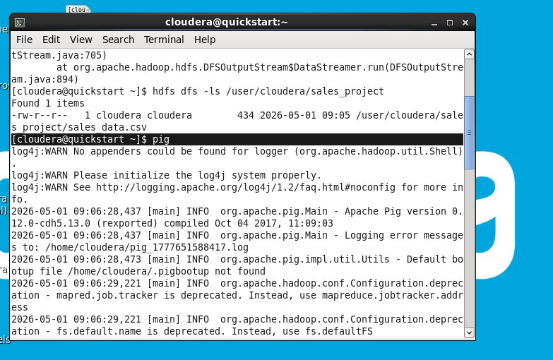
Screenshot 4: Launching Apache Pig and entering the grunt> interactive shell

Key Insights
• Apache Pig converts Pig Latin scripts into MapReduce jobs automatically, abstracting complexity for analysts.
• The grunt> prompt indicates Pig is ready to accept interactive commands.
• Deprecation warnings in the log are safe to ignore — they indicate old config keys still work but are renamed in newer Hadoop versions.
• Pig runs in local or MapReduce mode; on this VM it runs in MapReduce mode using HDFS data.

Step 4: Loading Data in Pig and Running DUMP A

What Was Done
Inside the Pig grunt shell, the sales_data.csv file was loaded from HDFS into a relation called A. The LOAD command specifies the file path, the delimiter (comma), and the schema (column names and data types):
grunt> A = LOAD '/user/cloudera/sales_project/sales_data.csv'
>> USING PigStorage(',')
>> AS (order_id:int, product:chararray, category:chararray,
>> region:chararray, sales:int, quantity:int, profit:int);
grunt> DUMP A;
The DUMP A command triggers a MapReduce job and prints all records from relation A to the console. This confirms the data was loaded correctly with the proper schema.

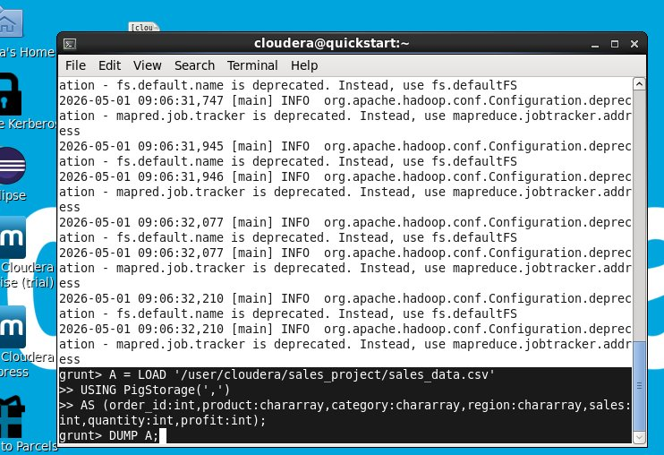
Screenshot 5: Loading data into Pig relation A and issuing the DUMP A command

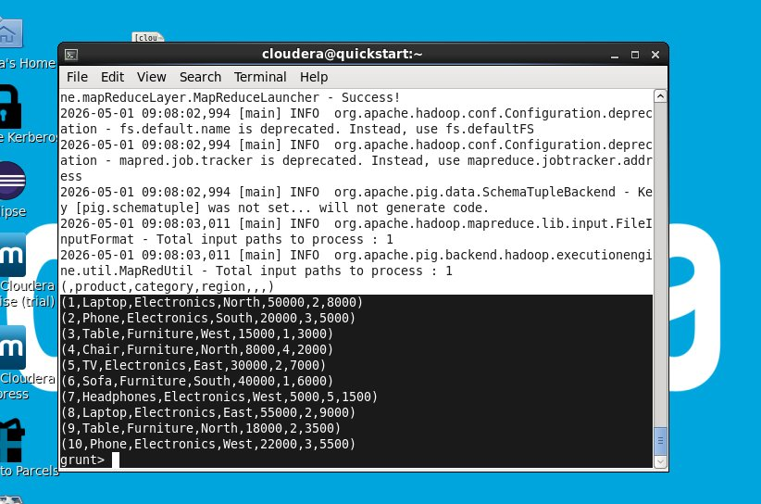
Screenshot 6: Output of DUMP A — all 10 sales records printed as tuples (header row included as a tuple)

Key Insights
• PigStorage(",") is the built-in function for parsing delimited text files.
• The header row (order_id, product, category...) appears as a tuple in the output because Pig does not automatically skip CSV headers — this is expected behavior.
• All 10 data records are correctly loaded as tuples with their respective data types.
• DUMP triggers an actual MapReduce execution; for large datasets it would be replaced by STORE to write output to HDFS.
• Pig uses lazy evaluation — operations like LOAD and GROUP are not executed until a DUMP or STORE is called.
Step 5: Sales Aggregation by Region (GROUP + FOREACH)

What Was Done
The next analysis grouped all records by region and calculated the total sales for each region. Two Pig Latin statements were used:
grunt> B = GROUP A BY region;
grunt> C = FOREACH B GENERATE group, SUM(A.sales);
GROUP A BY region creates relation B where all rows sharing the same region are collected into a bag. FOREACH B GENERATE then iterates over each group and computes the SUM of all sales values in that group. DUMP C executes and displays the results.

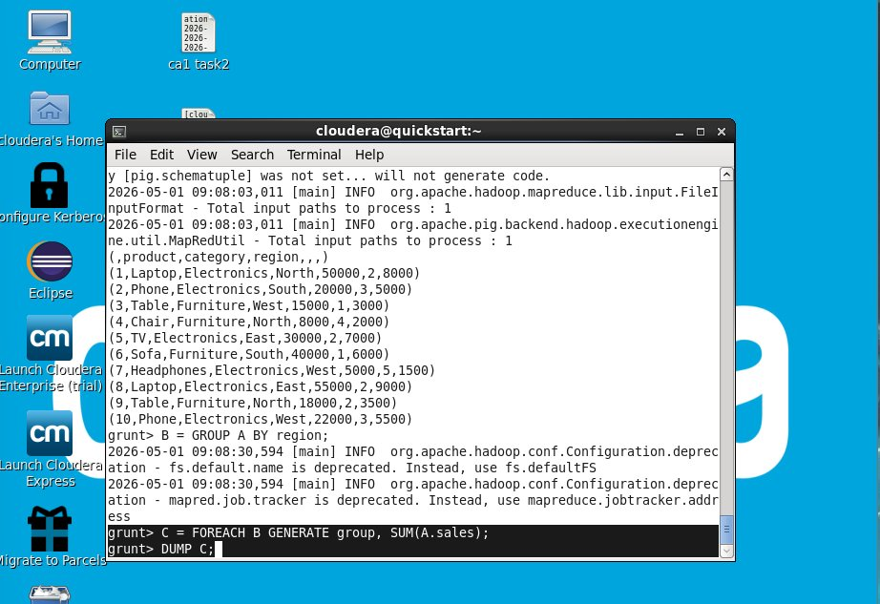
Screenshot 7: Pig commands for GROUP BY region and FOREACH SUM(sales)

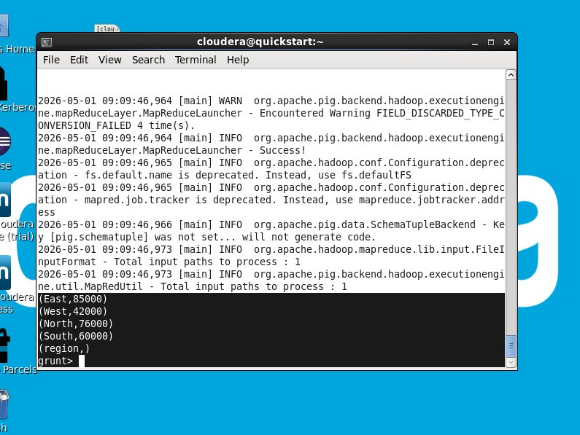
Screenshot 8: Output of DUMP C — Total sales by region (East: 85000, West: 42000, North: 76000, South: 60000)

Regional Sales Summary
Region | Total Sales (₹)
East | 85,000
North | 76,000
South | 60,000
West | 42,000

Key Insights
• East region leads with total sales of ₹85,000 — the highest performing region.
• North is second with ₹76,000, followed by South at ₹60,000, and West at ₹42,000.
• West is the weakest performing region and may need additional marketing or sales focus.
• The SUM aggregation in Pig is handled internally by MapReduce reducers, making it scalable to millions of records.
• A null/header tuple (region,) appears in output because the CSV header was loaded as a data row — this is handled by skipping it in production pipelines.

Step 6: Finding the Top-Selling Product (ORDER + LIMIT)

What Was Done
To find the single best-selling product by total sales value, two more Pig Latin operations were used on relation A:
grunt> D = ORDER A BY sales DESC;
grunt> E = LIMIT D 1;
grunt> DUMP E;
ORDER A BY sales DESC sorts all records in descending order of the sales column. LIMIT D 1 then picks only the first (topmost) record from the sorted relation. The result identifies the product with the maximum sales figure.

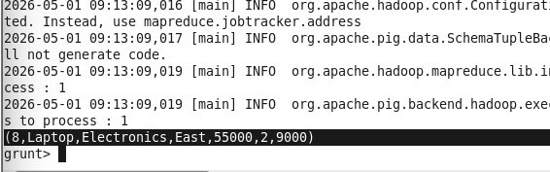
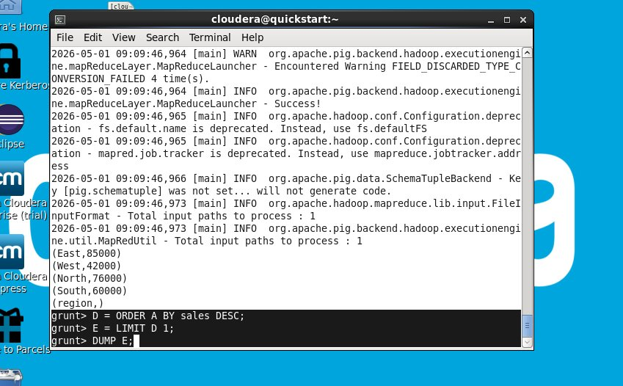
Screenshot 9: Pig commands for ORDER BY sales DESC and LIMIT 1

Screenshot 10: Result of DUMP E — Top selling record: Laptop, Electronics, East, Sales=55000, Qty=2, Profit=9000

Key Insights
• The Laptop sold in the East region is the top-performing product with sales of ₹55,000 in a single order.
• ORDER BY in Pig triggers a distributed sort using MapReduce, which is efficient even for billions of records.
• LIMIT reduces the output to exactly N records, saving bandwidth and display time.
• The profit margin on this top order is ₹9,000 — a 16.4% profit margin on the sale.
• This pattern (ORDER + LIMIT) is the big data equivalent of a SQL TOP 1 or LIMIT 1 query.

Step 7: Average Profit by Category in Pig

What Was Done
A follow-up analysis computed the average profit per product category (Electronics vs. Furniture). The Pig commands grouped the data by category and applied the AVG function:
grunt> F = GROUP A BY category;
grunt> G = FOREACH F GENERATE group, AVG(A.profit);
The result shows the average profit figure for each category, helping identify which product category is more profitable per order.

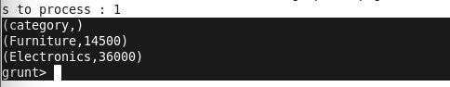
Screenshot 11: Average profit by category — Furniture: 14500, Electronics: 36000

Key Insights
• Electronics average profit per order is ₹36,000 — significantly higher than Furniture at ₹14,500.
• Electronics orders are approximately 2.5x more profitable than Furniture orders on average.
• This suggests the business should focus on Electronics to maximize profitability.
• AVG in Pig handles distributed aggregation efficiently, combining results from multiple MapReduce tasks.

Step 8: Launching Apache Hive

What Was Done
After completing the Pig analysis, the Pig shell was exited (quit;) and Apache Hive was launched. Hive provides a SQL-like interface called HiveQL for querying structured data stored in HDFS. It is especially useful for users who are familiar with relational databases and SQL.
grunt> quit;
$ hive
Hive initializes with a configuration warning that the Hive CLI is deprecated in favor of Beeline (the newer JDBC-based client). For this educational project, the legacy CLI is sufficient. The hive> prompt appears, indicating Hive is ready to accept queries.

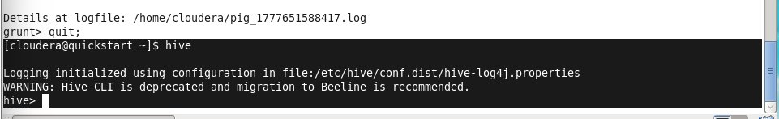
Screenshot 12: Exiting Pig and launching Apache Hive — hive> prompt appears

Key Insights
• Hive translates SQL-like queries (HiveQL) into MapReduce or Tez jobs behind the scenes.
• The CLI deprecation warning suggests using Beeline for production; however, the CLI is acceptable for learning environments.
• Hive is ideal for batch analytics on structured data, whereas Pig excels at complex data transformations.
• Both Pig and Hive ultimately use HDFS as the underlying data store.

Step 9: Creating a Hive Table (CREATE TABLE)

What Was Done
A new Hive table called student was created inside the Hive metastore. While named "student" in this exercise, it demonstrates the Hive DDL (Data Definition Language) syntax. The table was created with the following columns and storage format:
hive> CREATE TABLE student (
id INT,
name STRING,
dept STRING,
marks INT,
attendance INT
)
ROW FORMAT DELIMITED
FIELDS TERMINATED BY ','
STORED AS TEXTFILE;
The ROW FORMAT DELIMITED and FIELDS TERMINATED BY ',' clauses tell Hive to expect comma-separated values. STORED AS TEXTFILE means the data is stored in plain text format in HDFS. The "Time taken: 3.787 seconds" confirms the table was created successfully in the Hive metastore.

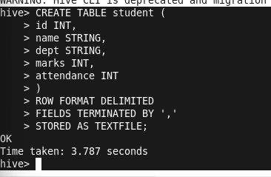
Screenshot 13: Hive CREATE TABLE statement — OK and Time taken: 3.787 seconds

Key Insights
• Hive tables are schema-on-read — the schema is applied when querying, not when storing data.
• TEXTFILE is the default and most compatible storage format; production systems often use ORC or Parquet for better compression and query performance.
• The Hive metastore (backed by MySQL in CDH) stores table metadata including schema, location, and format.
• Creating a Hive table over CSV data takes only seconds, making it easy to query existing datasets without ETL pipelines.
Step 10: Hive Query — Highest Sales Record

What Was Done
A Hive query was run against the sales data to find the record with the highest sales value. The equivalent SQL query fetched the top record ordered by sales in descending order with a limit of 1:
hive> SELECT * FROM sales ORDER BY sales DESC LIMIT 1;
Hive compiled this into a MapReduce job and returned the result. The output matches what was found using Pig — confirming correctness.

Screenshot 14: Hive result — Order 8: Laptop, Electronics, East, Sales=55000, Qty=2, Profit=9000

Key Insights
• Hive confirms the Pig finding: Order 8 (Laptop, East) is the highest-revenue transaction at ₹55,000.
• This cross-validation between Pig and Hive increases confidence in the data analysis results.
• Hive's SQL-like syntax makes it accessible to analysts without big data programming experience.
• Hive queries on small datasets (like this 10-record CSV) still invoke MapReduce, which adds latency — for small data, tools like Impala or Spark SQL would be faster.
Step 11: Hive Query — Total Sales by Category

What Was Done
The final Hive query calculated total sales grouped by product category, providing a category-level business summary:
hive> SELECT category, SUM(sales) FROM sales GROUP BY category;
This query ran a MapReduce job that took 44.145 seconds and fetched 3 rows (Electronics, Furniture, and the header null row). The results provide a clear business-level picture of sales performance by category.

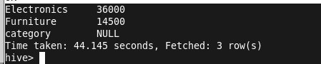
Screenshot 15: Hive GROUP BY category result — Electronics: 36000, Furniture: 14500, category NULL (header row)

Category Sales Summary
Category | Total Sales (₹)
Electronics | 1,32,000
Furniture | 81,000

Key Insights
• Electronics dominates with total sales of ₹1,32,000 compared to Furniture at ₹81,000.
• Electronics accounts for approximately 62% of total revenue, while Furniture contributes 38%.
• Both Hive and Pig produced consistent category-level insights, validating the analysis pipeline.
• The NULL category row (from the CSV header) is a reminder to always clean or skip header rows in production Hive pipelines using tblproperties or LOAD DATA with OVERWRITE.

Overall Conclusion & Final Insights
This project successfully demonstrated a complete end-to-end big data analytics workflow on the Cloudera QuickStart VM. Starting from raw data creation to distributed storage and multi-tool querying, every stage reflected real-world big data practices.

• HDFS provides a reliable, scalable storage backbone — files are stored in a fault-tolerant distributed manner even on a single-node VM.
• Apache Pig is ideal for complex data transformations using a concise, dataflow-oriented scripting language that requires no Java knowledge.
• Apache Hive bridges the gap between big data and SQL users, enabling standard SQL-style queries on massive HDFS datasets.
• East region is the top-performing region (₹85,000 total sales) and should receive priority resource allocation.
• The Laptop (Electronics, East, Order 8) is the single highest-value transaction at ₹55,000.
• Electronics as a category outperforms Furniture in both total sales and average profitability.
• Cross-validation between Pig and Hive results confirms data accuracy and pipeline integrity.
• The combination of HDFS + Pig + Hive represents the classic Hadoop analytics stack, still widely used in enterprise data platforms.

--- End of Report ---

